DANGER School

With below database schema (ERD) of DANGER School, we will join the tables and select data accordingly with SQL:

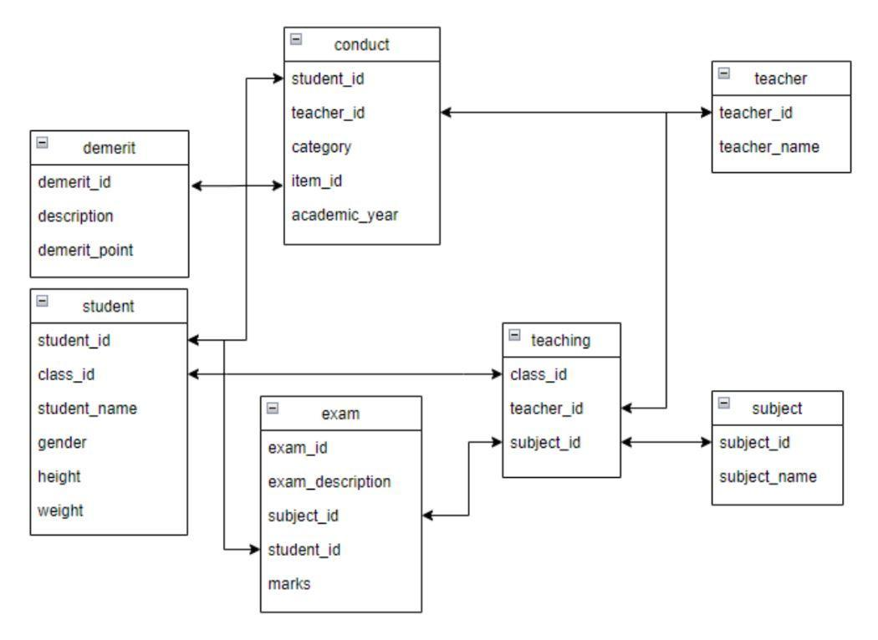

Q1.
Select a table including below columns:
- class id
- subject name
- teacher name

Q2.
Select a table including below columns:
- exam marks
- student height

Q3.
Select a table including below columns:
- exam id
- exam description
- subject id
- student id
- exam marks
- teacher name

Q4.
Select a table including below columns:
- student name
- exam description
- exam marks
- subject name
- teacher name

Q5.
Calculate BMI for each student with below columns:
- student name
- BMI (i.e. BMI = weight(kg) / height(m)^2)

